EXPERIMENT – 2
AIM:
To create a simple cloud software application for Flight Reservation System using any Cloud Service Provider to demonstrate SaaS.
PROCEDURE:
- A cloud service provider platform is selected to develop and host the application as Software as a Service (SaaS).
- A cloud application named “Flight Reservation System” is created to manage airline and flight reservation operations online.
- An Airlines module is designed to store airline details required for flight operations.
- A Flights module is created to maintain flight information such as flight number, source, destination, and schedule.
- A Passengers module is implemented to store passenger details necessary for booking flights.
- A Reservations module is developed to manage flight booking by linking airline, flight, and passenger details.
- Lookup fields are used to establish relationships between airlines, flights, passengers, and reservations.
- Dropdown fields are configured to ensure standardized and error-free data entry.
- All application data is stored securely on the cloud and can be accessed by authorized users through a web browser.
- The application is deployed on the cloud and accessed without installing any local software, demonstrating the SaaS model.

RESULTS:
1.
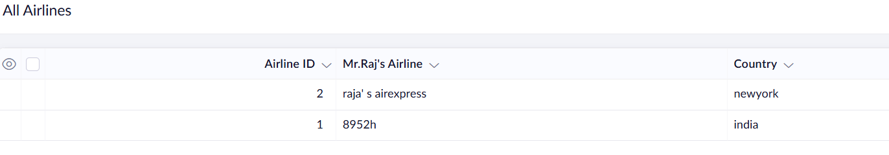
2. 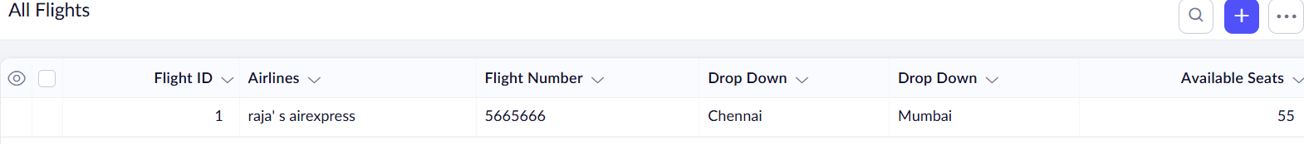
3. 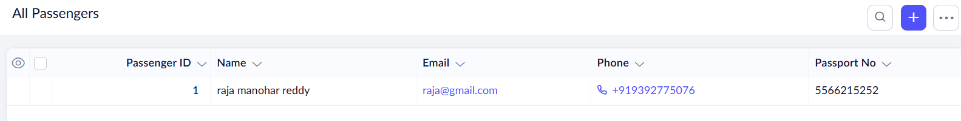
4.
